TB2 Usability Test Project

Skyscanner

Table of Contents

1. Introduction and Background 3

1.1.1: Recent Developments and Trends. What real world changes in business or society set the context for this usability test? 3

1.1.2: Why are these trends important and of interest to many people? Which system /software /website are you going to test? 3

1.1.3: What organisation ‘owns’ the software? What are the business goals of the software? 4

1.1.4: How does usability and user experience enable these business goals? 4

1.1.5: Why is it timely to evaluate usability and user experience now? why evaluate it now? 4

1.2. The Existing User Interface 4

2. Aims 8

Prior Testing 8

Main Testing 8

Post Testing 9

Task 1 – Insert flight destination and date. 9

Task 2 –Select a flight price. 9

Task 3 – Book Flight 9

3. Method 10

3.1 Method overview 10

3.2 Participants 11

3.3 Tasks 12

3.4 Metrics 13

3.5 Materials and Tools 14

3.6 Procedure 14

4. Results & Recommendations 18

4.1 Written summary of overall findings 18

4.2 Performance Data 19

Task 1 – Insert flight destinations and dates. 19

Task 2 – Select a flight price. 20

Task 3 – Book flight. 21

4.3 User Experience Issues success 22

4.4 Redesign Recommendations 24

5. Discussion and Conclusion 26

6. Appendices 27

# 1. Introduction and Background

## 1.1.1: Recent Developments and Trends. What real world changes in business or society set the context for this usability test?

Usability tests analyse areas where general people struggle with the use or purpose of a product and help guide a business or society by making recommendations for any improvements that can be made. Importantly, usability tests thus allow us to gain a stronger understanding about how users interact with products, which results in product improvements as a result of user feedback. By doing this, the main purpose of a usability test is to improve the functionality and design of the product or service.

Within the usability test, the user’s aims are to achieve the tasks and goals from the product within coordinated conditions. When this process is being held, the stakeholders, developers and researchers observe the results to collect data. Whilst usability testing employs what the customer gains in the task, this can also provide objective performance data, for example insights into the errors that occur, the time it takes to complete the task and the task success rate. Another crucial factor with testing is that there are no conditions for watching users struggle when completing tasks, as this will help the product design team make changes and alternative designs which support the product and workflow.

When a business or society conduct any testing, they need to gain the greatest amount of information from the testing to accomplish the user understanding about the product and service provided. By doing this, they need to ask for feedback from the following:

* Background: The product description and use with reasons for requesting feedback.
* Usability Goals: What you expect to learn from the tests.
* Participants: The quality from participants through characteristics of customer and users of the product.
* Timeline: A timetable for when a product is ready for testing and the result discussions with the team.
* Key Points: The actions and features taken within the test tasks have to be covered. This can include specific questions that the team want answered.
* Additional information: All things related to testing should be taken into consideration.

## 1.1.2: Why are these trends important and of interest to many people? Which system/software/website are you going to test?

The goal within the usability testing is to have a better understanding of how real users interact with the product or service, which is reflected in the feedback that enables one to make changes to better improve the service from user requests. It is important for a business to be certain that the app, website or product is efficient to navigate with ease in completing tasks. If this is not achieved, the risks of losing the customer to a competitor is high. Furthermore, the key factors within the importance to people of usability testing, is the gathering of data needed to improve website services and or the product as a whole. The website I will be testing is Skyscanner, a flight comparison website allowing users to book flights, hotels and rent cars in global destinations.

## 1.1.3: What organisation ‘owns’ the software? What are the business goals of the software?

Skyscanner is an online travelling website run as a flight comparisons site based in Edinburgh, Scotland. It is owned by Trip.com Group, the largest online travel agency based in China. Skyscanner is available in over 30 different languages making it compatible for a global market and is used by over 100 million customers globally every month. Their businesses goal is to maintain and increase the number of customers using Skyscanner. To do this, they introduce website improvements, making it user friendly and easy to navigate.

## 1.1.4: How does usability and user experience enable these business goals?

Usability and user experience testing allow Skyscanner to obtain users perspectives, enabling them to identify the downsides and areas of improvement for the website. As the goal is to maintain a high number of customers using Skyscanner, usability testing and feedback enables the Skyscanner team to constantly create new website designs for the pages, functions, navigation and just the general look of the website, such as the fonts, text size and colours. These changes have the potential to draw customers in visually, but also through ease of functionality, i.e. booking holidays. Another factor that can be touched on with improving the website is the ratings. This allows the user to leave feedback of their experience from using the website, and any issues when navigating which can then be analysed by the team and improved at later stages.

## 1.1.5: Why is it timely to evaluate usability and user experience now? Why evaluate it now?

Evaluating Skyscanner is crucial as online flight and holiday websites are gaining traction year by year, becoming the most popular form of holiday booking, thereby putting store travel agents at a loss. Consequently, these websites have to meet the ease of old fashion travel agents but apply such a simplicity to self-booking. Therefore, ease of navigation is crucial. The website must be efficient and user friendly to minimize any confusions which was previously eliminated by having a travel agent sort out your bookings.

## 1.2. The Existing User Interface

Skyscanner has a very smooth flow with its page layout divided into sections (as seen below) which split all travel information and recommendations, giving the impression that you can use the website as a service to find holiday and destination recommendations even if the user is unsure about their choices. The first screenshot shows the flight, hotels and car hire search bar which allows the user to manually enter departures and destinations through return, one-way and multi-city tickets, allowing a wide range of options to choose from.

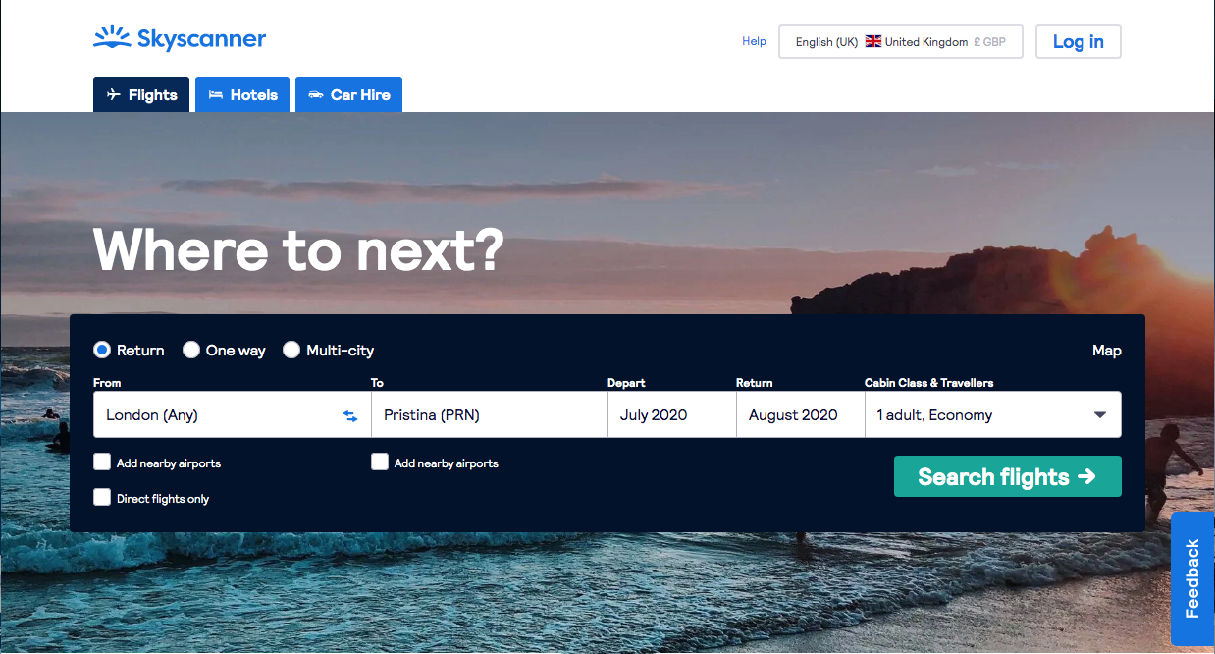

The below shows the ‘recommendations for you’ section in the home page. The division of sections of the front page creates a simple to use layout, making the website more appealing and user-friendly, thereby attracting a wider age band audience. The ‘recommendations for you’ section show destinations near the area that you have previously looked for in the past. This feature is impressive as the website tracks your preferences and offers a wide range of recommendations that best describes your holiday searches. This is an attractive feature for the user as the website meets the requirements of an in store travel agents who would normally provide recommendations to guide your search.

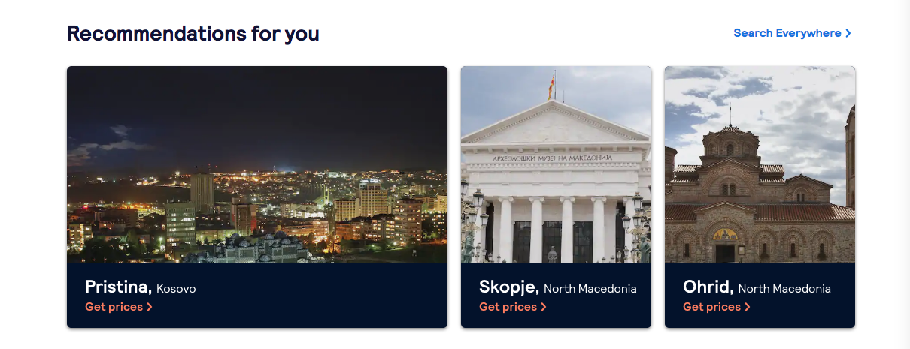

Moving onto the bookings section of the website, the page layout is clear and easy to navigate for the user. The screenshot below shows that the user has various options; ‘best’, ‘cheapest’ and ‘fastest’ ticket deals, allowing the user to have more than one option when selecting price deals and route times. This differs from each selection from direct tickets to one stop tickets with their different pricings. One slight issue however is that the bookings page does not have a appropriate tool bar at the top to navigate back to the home page or possibly change the destination airports.

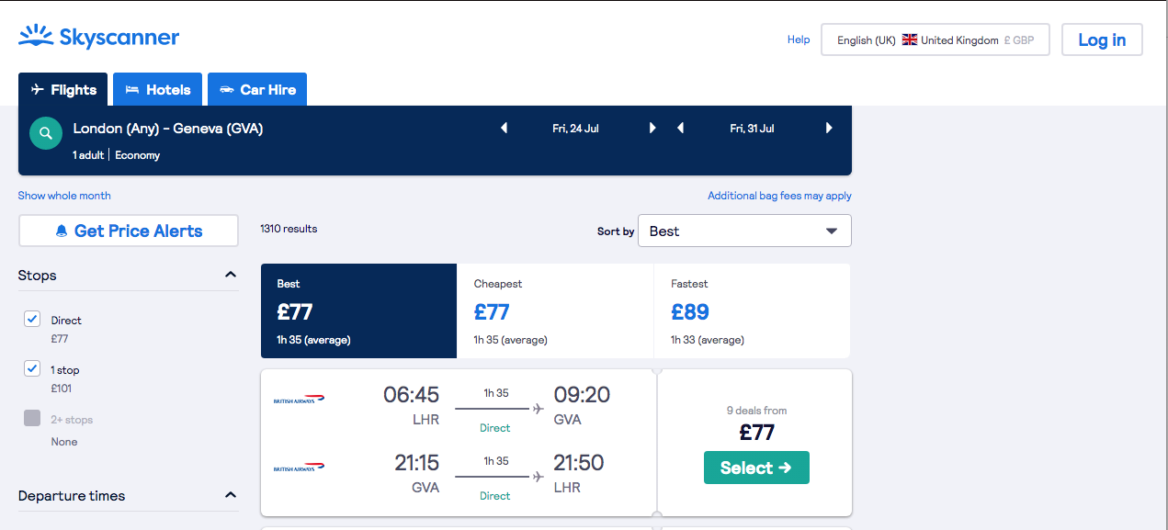

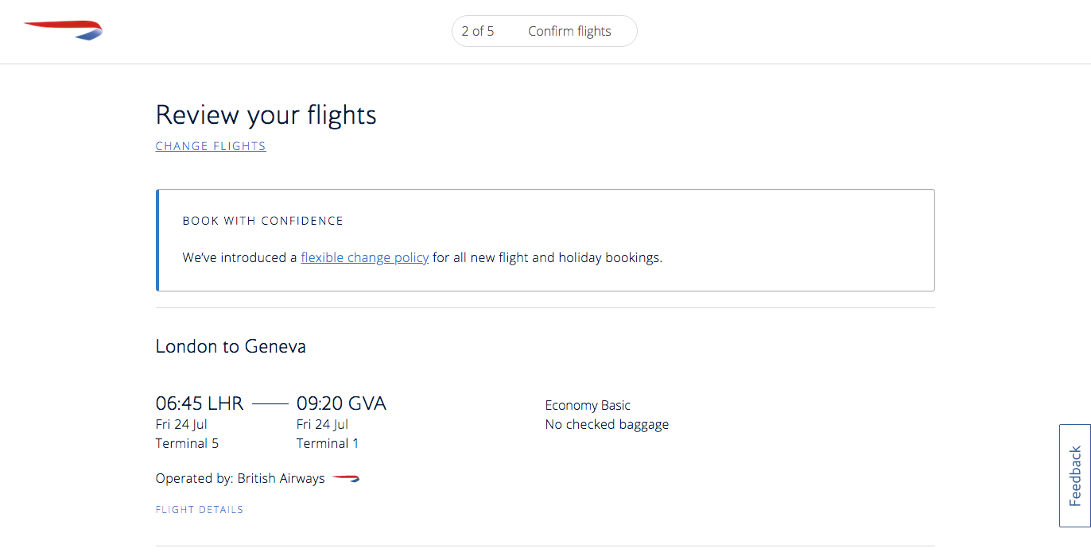After selecting your ticket, Skyscanner diverts you to the airliner website where the user will enter their details.

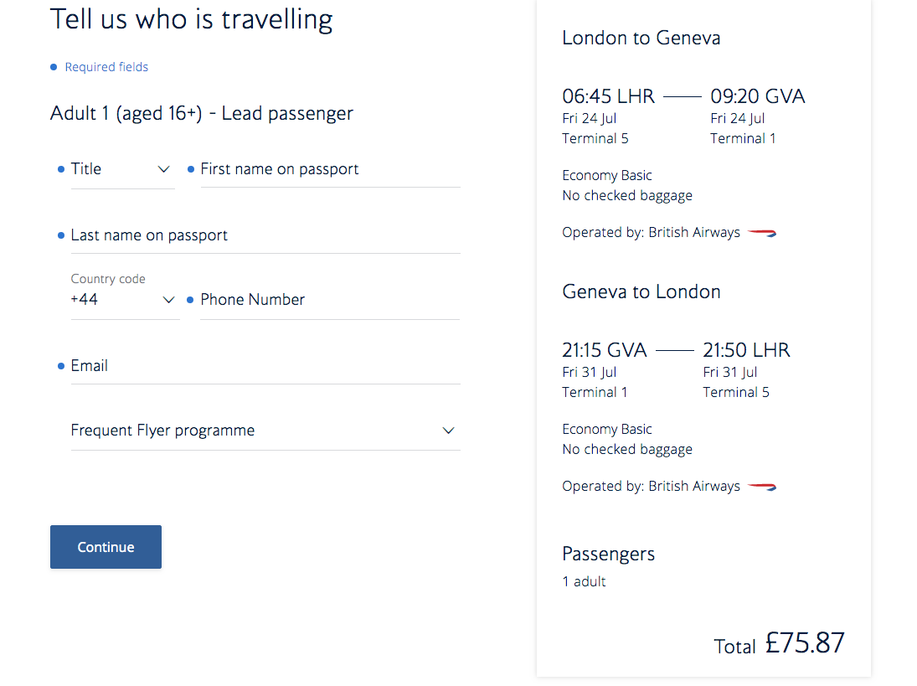

# 2. Aims

The purpose of usability testing is to obtain the users point of view of the website. By doing this, the users can indicate experiences of the website; what they liked and disliked, and the general look and feel of the website such as the navigation. These can all influence recommendations. This will allow me to evaluate all user feedback, giving me a greater understanding of user issues, enabling me to redesign and enhance the user experience.

The method that will be used to obtain user testing is through a questionnaire that users will answer through a live Zoom meeting which will be screen recorded. Within the questionnaire, I will have a set of questions relating to the functions of the website, the navigation and the looks of the pages, such as the colour and fonts. By using a questionnaire and a live meeting, my users can provide their thoughts which will be collected as raw data to then be analysed. This method of raw data collection is effective as it provides initial and original thoughts, much like those experienced by a Skyscanner customer. Additionally, I will also provide the tester with a task sheet and task questions that they will answer at the end of the test.

|  |  |
| --- | --- |
| Prior Testing | **Reasons for questions** |
| Name and age | Tester introducing themselves |
| How many times a year do you travel abroad? | Asking the tester the amount of times they travel abroad can indicate whether they use/are experienced with online booking websites and services often or not. |
| What do you use to book your tickets? | Tester can use many different types of bookings such as online and through an agent. |

|  |  |
| --- | --- |
| Main Testing | **Reasons for questions** |
| What are your thoughts about each page? | This question obtains the users opinion on the structure and look of the page and could potentially give away what they like and dislike. |
| What do you think about the navigation of the website and how easy was it to use? | Tester can state any problems they come across with navigation that can cause confusion. |
| What are your thoughts about the colour scheme across all the pages? | Tester can give their thoughts about the colours used. Whether the pages seem monotonous or eye catching. |
| What are your thoughts about the font sizes and styles? | Tester can state whether the font size was appropriate or difficult to read. |
| Do you think that the text on the pages are spread out evenly around the page? | Tester can state their thoughts about the layout of information on the page and how it is divided. |
| Do you think that the time it took to complete the tasks on each page was efficient? | Tester can give their thoughts about efficiency, or lack of, when completing tasks. |

|  |  |
| --- | --- |
| Post Testing | **Reasons for questions** |
| What did you like about the website? | Tester can indicate the features and/or functions they liked about the website. |
| What did you dislike about the website? | Tester can indicate the features and/or functions they disliked about the website. |
| Did you come across any confusions within the website through completing tasks or navigation? | Tester can state any confusions they came across when using the website. |
| Was there anything you expected to see on the website that wasn’t there? | Tester can indicate any options or functions that could be added to improve the website. |
| On a scale of 1 to 10, how likely would you recommend this website to friends and family? | This question indicates the testers experience and at what level they would recommend it to others. |

**Task Questions**

## Task 1 – Insert flight destination and date.

|  |  |
| --- | --- |
| **Task Question** | **Reasons for question** |
| Rating 0 to 5, how easy was this task (0 = hard, 5 = easy). | This allows the user to rate the easiness of the task for data collection. |
| Overall, what are your thoughts on the navigation of insert flight destination and date task? | This allows the user to comment on any navigation difficulties when completing this task. |
| Overall, what are your thoughts on the layout of the insert flight destination and date task? | This allows the user to comment on the features with background colours/styles. |

## Task 2 –Select a flight price.

|  |  |
| --- | --- |
| **Task Question** | **Reasons for question** |
| Rating 0 to 5, how easy was this task (0 = hard, 5 = easy). | This allows the user to rate the easiness of the task for data collection. |
| Overall, what are your thoughts on the navigation of selecting a flight price? | This allows the user to comment on any navigation difficulties when doing this task. |
| Overall, what are your thoughts on the layout of the flight price selection section? | This allows the user to comment on the features with background colours/styles. |

## Task 3 – Book Flight

|  |  |
| --- | --- |
| **Task Question** | **Reasons for question** |
| Rating 0 to 5, how easy was this task (0 = hard, 5 = easy). | This allows the user to rate the easiness of the task for data collection. |
| Overall, what are your thoughts on the navigation of flight booking section? | This allows the user to comment on any navigation difficulties when doing this task. |
| Overall, what are your thoughts on the layout of flight booking section? | This allows the user to comment on the features with background colours/styles. |

# 3. Method

## 3.1 Method overview

The purpose of customised common industry format (CIF) is to provide consistency when evaluating usability testing procedures and collecting all results. The customised section of CIF within my example from the online booking website Skyscanner, provides a descriptive example for online bookings proposed for both collective and formative usability testing.

CIF is an outline for the use of reporting usability testing methods and collection of results. With this, by delivering the standard outline, you can demonstrate the evidence of usability activities within the format that allows comparison through different products, and the independent evaluation for tasks within a single product. User experience and usability professionals use, report and analyse using CIF. As I am carrying out usability testing through user experience, it is beneficial that the CIF model is used within the project. Evaluators and application usability such as providers make informative choices regarding the release of websites and software applications. With this comes the evaluation of application usability test results. Another user of CIF is stakeholders within organisations.

CIF covers the measures for effectiveness and efficiency with recommendations comprising subjective satisfaction data collections. This is very efficient with the usability testing as data collection is based on these points from the user. The measures for efficiency includes the task time, how long it takes to complete the task, the efficiency when navigating through the website, completion rate efficiency and the number of references to the manual. This includes the use of clear instructions, whether the user understand how to use the website and whether any confusions exist.

The measures of effectiveness include the completion rate, how long it takes for the user to complete the task, the reason it took that amount of time and whether there were issues with the website. The number of errors is another measure which interlinks with completion rate as it affects the time it takes for the tester to complete the task.

The measures of satisfaction include the system usability scale also known as the SUS. This is the final evaluation showcasing the users thoughts about the website at the end of the testing. This system is a simple answer sheet layout with a scale from one to five (one being ‘strongly disagree’ and 5 being ‘strongly agree’) giving a global view of the subjective assessment.

When answering research questions within usability testing, a one-shot experiment design is an efficient way to do this. This is a pre experimental type design which are specifically used for researching. There are three different types of pre-experimental designs, these are:

* One-shot case study design
* One-group pretest-posttest design
* Static-group comparison

The one-shot case study design consists of a single group which is studied at a single point in period after a treatment, which is presumed to have caused any changes taking place. This therefore means that it is carefully studied within a single time, which is then compared to the general expectations for what the case would look like had the treatment not happened, with other events observed. This could be a comparison between competitors within the online booking website sector through research. By doing this, we can collect data between what website the tester prefers with before and after data collection, allowing a direct answer and result.

## 3.2 Participants

|  |  |
| --- | --- |
| **Participant Name** | **Reasons** |
| Sadie Zharki | Market and Competitive Intelligence Analyst working at Sopra Steria, an IT company. Has taken part in internal client design platforms so has experience with usability testing. |
| Juxhen Bica | Family friend with an analysis background. |
| David Bica | Family friend with IT background. |
| Sarah Al Jamal | IT student at Kingston with analysis skills. |
| John Anestis | IT student at Kingston with analysis skills. |
| Veron Perzha | IT student at Middlesex with analysis skills. |

## 3.3 Tasks

The task that I have set for my participants is to carry out a questionnaire test through using the website. When doing this, they are set with an instructions sheet for them to carry out 3 different tasks during the test. The requirements are for the participant to take screen recordings of every event they carry out on the website within a Zoom meeting session, both through video and audio. Screen recording is important as I can analyse what the participant’s actions are, and it allows them to point out any issues they have come across within the website with the mouse clicker. Recording both video and audio allows me to see the participants body language when facing obstacles allowing me to analyse different frustration levels throughout, with the audio on top giving me the final answer for each question.

The task is laid out in a question sheet which has three sets of questions; prior questions, main questions and post questions. Setting the task in three stages allows me to separate the participants reply to each question. The main questions are general questions on looks, styles and functions of the website, whereas the post questions are indications of what the participant liked/disliked about the website and any issues or frustrations they came across. This therefore allows me to find out the participant’s experience from testing the website with their own thoughts towards it.

When carrying out the test, the participate is required to complete three different tasks. This includes searching for a flight and data, selecting a flight price and going through the booking process for the flight. This is supplied to the participant with a test requirements sheet alongside the questions for the testing.

## 3.4 Metrics

The UX criteria I will be using to undertake the usability testing is the CIF metrics model. The model will allow me greater consistency and visibility within describing the usability testing processes. From this, the lead up to processing and reporting the participant’s results is more efficient and accurate. Here is each section of the criteria:

|  |  |  |
| --- | --- | --- |
| **Criteria** | **Measures** | **Reasons** |
| Time to complete the task | The time to complete the task is measured from the start to the end in minute and seconds. | This metric will allow us to understand the flow of the tasks and how long it takes. |
| Number of errors | This is the number of errors that the tester comes across when completing the tasks within the test. | This metric will help us understand problems that the tester came across within the website. |
| Task success rate | The task success rate is measured with effectiveness which is task completed successfully divided with the total number of tasks taken by the tester, multiplied by 100. (TCT/T X 100) | This metric will help us analyse how successfully the tasks were completed. |
| Number of assists | This is the number of times a users question the set tasks or ask for help from the moderator. | This metric will help us identify which sections of the task the tester need help or guidance in indicating the need for change. |
| Time based efficiency | This measurement is the time taken for user to complete the task (Tij), with the result of task(Nij) divided by the number of task (N) and users (R)  ../Screen%20Shot%202020-04-16%20at%2013.22.41.png | This metric allows us to judge and evaluate the efficiency of the tasks within the website. |
| Single ease use answer (SEQ) | This measurement is from a single task question used to estimate the overall usability of the website. | This metric is an easy way to obtain quick data for the user journey task completion. |
| Subjective mental effort questions (SMEQ) | This measurement is a single task question do analyse the difficulty of the task. | This metric is easy to obtain through a rating scale of difficulty per task. |
| System usability scale score (SUS) | This measurement is where the x is the sum of total questions and is equal to the score of the questions ranging from 1 to 5. X * 2.5 | This metric allows us to measure how usable the task was. |

## 3.5 Materials and Tools

When carrying out the usability tests, I will be providing the participant with the questionnaire worksheet. The questions will be laid out in bold text so that it is clear for the tester to read and understand, and it will also be in a numbered format, indicating three different sections: prior questions, main questions and post questions. This makes it easier for the participant to visually see what section of the test they are on, giving them an idea of the type of answers they should be providing. I will also be providing the participant with a task instruction brief for them to gain knowledge on how the testing is going to take place and proceed. With this, they will be supplied with the three tasks. They will then answer separate questions on this. On my side of the usability testing, I will have the question sheet where I will record all answers given by the participant per question to collect all data provided.

## 3.6 Procedure

Each test was carried out with an individual recording where the participants used QuickTime Player to screen record with audio and video through a Zoom meeting. Within these recordings, each participant was supplied with the questions and guidance sheet To carry out the tests. Below is the set of documented screenshots of the participants taking part in the usability testing:

Participant 1: Sadie Zharki.

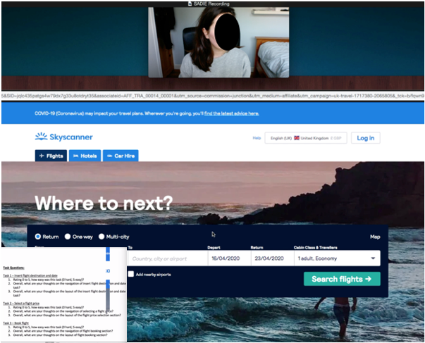

Participant 2: Juxhen Bica

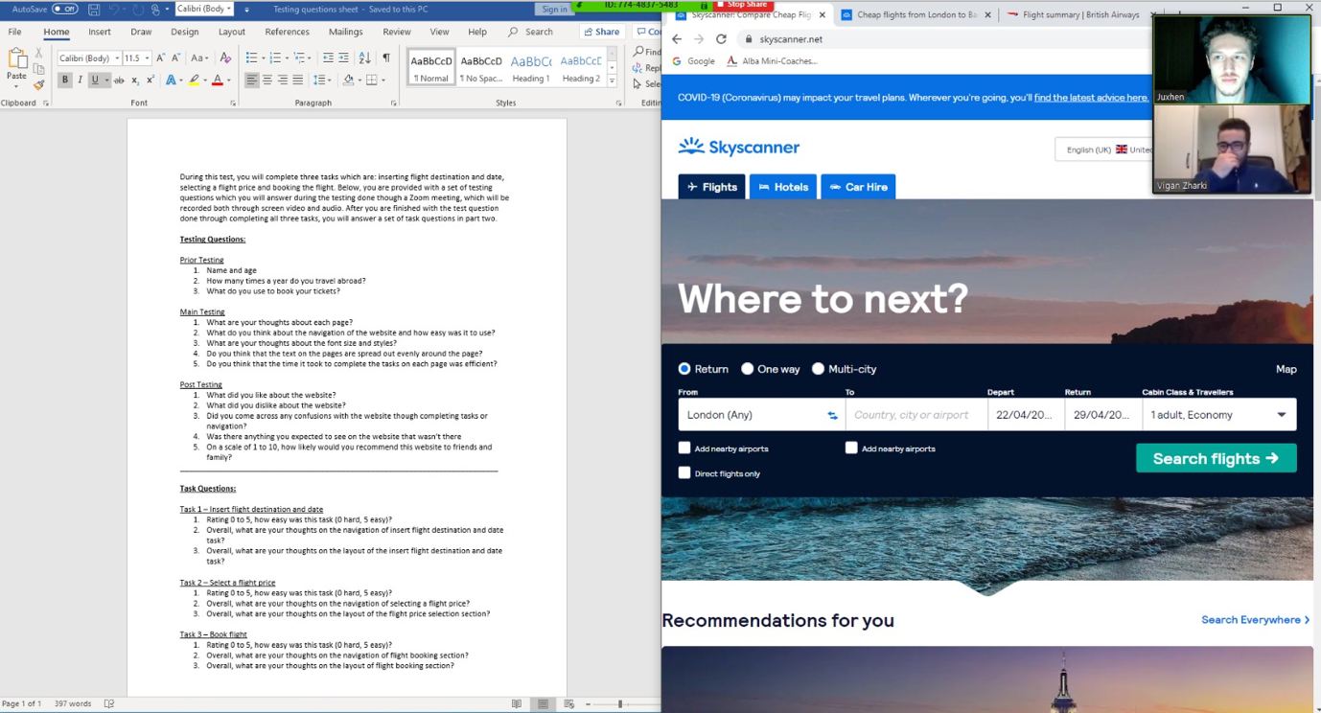

Participant 3: David Bica

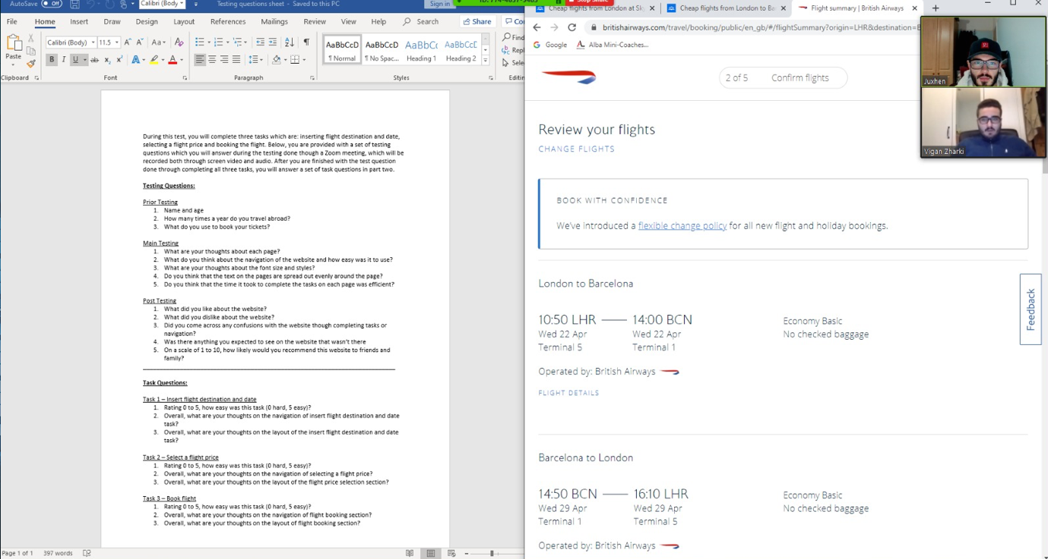

Participant 4: Sarah Al Jamal

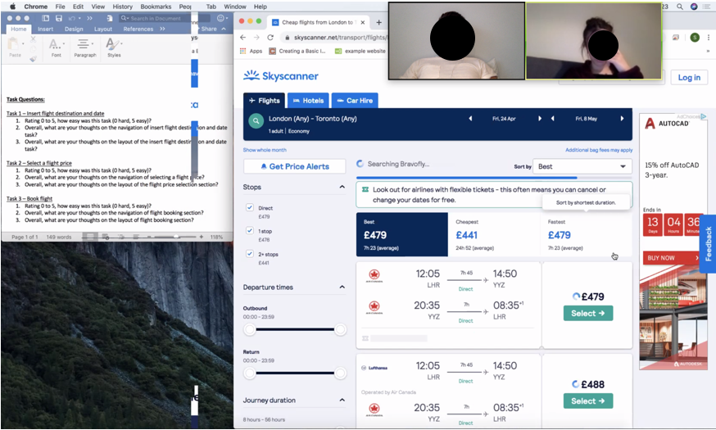

Participant 5: John Anestis

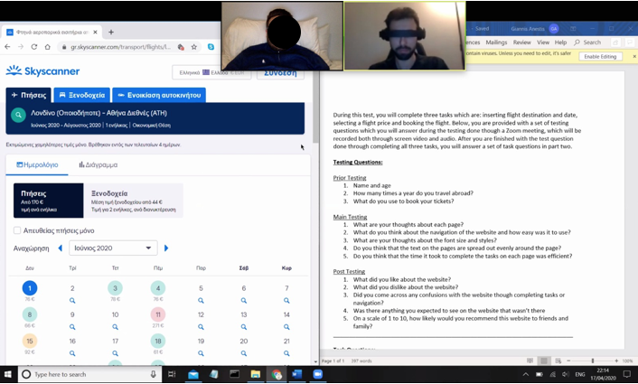

Participant 6: Veron Perzha

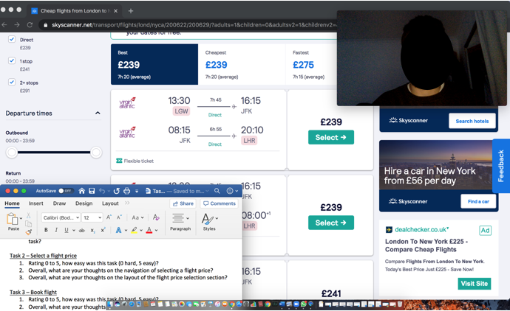

# 4. Results & Recommendations

## 4.1 Written summary of overall findings

The usability testing process went well and according to plan and all the participants took part with the questionnaire, tasks and recordings. They all analysed the website, giving their opinion about the positives of the website, elements that could be improved and issues that they came across. From collecting all of their answers, one issue they all came across was that Skyscanner did not have any source of help and guidance through a live chat box, particularly for the older age generations which have less experience in using the web. This should be a key issue to resolve as it will help individuals use and understand the website better.

Another issue that all participants came across was that there is no option for the user to select flights, hotels and car rentals all at once. Participants stated that users may want to book this all in one price, likewise in other online booking websites, they allow package bookings which include pick up/drop off to and from the airport and hotel. This issue should be addressed as it will give the user more flexibility when booking, whilst providing greater efficiency.

There was also a slight issue with the ticket booking page where my participants commented the selected tickets section diverted them to the airliner website. There is a general preference to keep bookings on the same Skyscanner website instead of transferring them to the airline website to fill in personal details and conduct payments. This would reduce the confusion of navigating through a foreign airline website.

Finally, there was a slight issue with the look of the pages. Pages were deemed plain and lacking in colour, primarily due to the website’s simplicity. A more diverse colouring scheme would make the website more eye catching and appealing.

Aside from this issues, all participants where happy with the function of the website through its easy to navigate friendliness. There were some good comments on the images used within the homepage stating that it inspired them to travel. Participants also enjoyed the recommended holiday destinations, and particularly liked the use of images to show the different beaches and sceneries recommended to them through search history. They also enjoyed Skyscanner’s consideration towards users travelling on a budget by providing them with good holiday deals.

## 4.2 Performance Data

## Task 1 – Insert flight destinations and dates.

|  |  |  |  |
| --- | --- | --- | --- |
|  | **Rating 0 to 5, how easy was this task (0 hard, 5 easy).** | **Overall, what are your thoughts on the navigation of insert flight destination and date task.** | **Overall, what are your thoughts on the layout of the insert flight destination and date task.** |
| **Participant 1** | 5 | Participant 1 commented that the navigation of the task was simple to use. | Participant 1 commented that the layout was clear and easy to understand. |
| **Participant 2** | 4 | Participant 2 commented that the navigation was straight forward. | Participant 2 commented that the colour schemes and fonts where really good and they liked the background image. |
| **Participant 3** | 4 | Participant 3 commented that the navigation was easy when handling the task. | Participant 3 commented that the layout was very clear. |
| **Participant 4** | 5 | Participant 4 commented that the navigation was understandable to use. | Participant 4 commented that the layout was clear and readable. |
| **Participant 5** | 4 | Participant 5 commented that the navigation was clear to navigate. | Participant 5 commented that the layout was simple and understandable. |
| **Participant 6** | 5 | Participant 6 commented that the navigation was easy to understand. | Participant 6 commented that the layout was very clear and eye catchy. |
| **Average Total:** | **4.5** | **Overall excellent** | **Overall excellent** |

## Task 2 – Select a flight price.

|  |  |  |  |
| --- | --- | --- | --- |
|  | **Rating 0 to 5, how easy was this task (0 hard, 5 easy).** | **Overall, what are your thoughts on the navigation of selecting a flight price.** | **Overall, what are your thoughts on the layout of the flight price selection section.** |
| **Participant 1** | 5 | Participant 1 commented that the navigation was very simple. | Participant 1 commented that the layout was clear for the text however could be improved with more images and colours. |
| **Participant 2** | 4 | Participant 2 commented that the navigation was easy to use. | Participant 2 commented that the layout was clear to read and understand but there was too many plain spaces on the page. |
| **Participant 3** | 4 | Participant 3 commented that the navigation was straight forward to use. | Participant 3 commented that the layout was easy to read. |
| **Participant 4** | 4 | Participant 4 commented that the navigation was easy to use. | Participant 4 commented that the layout was clearly laid out. |
| **Participant 5** | 5 | Participant 5 commented that the navigation was understandable with no issues. | Participant 5 commented that the layout text was clear however the page was a bit plain. |
| **Participant 6** | 4 | Participant 6 commented that the navigation was clear and user friendly. | Participant 6 commented that the layout was clear to read. |
| **Average Total:** | **4.3** | **Overall excellent** | **Overall average** |

## Task 3 – Book flight.

|  |  |  |  |
| --- | --- | --- | --- |
|  | **Rating 0 to 5, how easy was this task (0 hard, 5 easy).** | **Overall, what are your thoughts on the navigation of flight booking section.** | **Overall, what are your thoughts on the layout of flight booking section** |
| **Participant 1** | 3 | Participant 1 commented that the navigation was okay but could be improved. | Participant 1 commented that the layout was okay. |
| **Participant 2** | 1 | Participant 2 commented that the navigation was annoying as the page is transferred to a different website. | Participant 2 commented that the layout was okay however could be better if the website didn’t change. |
| **Participant 3** | 2 | Participant 3 commented that the navigation was poor because of the switching websites. | Participant 3 commented that the layout was poor because of the switching website. |
| **Participant 4** | 2 | Participant 4 commented that the navigation was hard to use. | Participant 4 commented that the layout was poor. |
| **Participant 5** | 3 | Participant 5 commented that the navigation was difficult because of the switching website. | Participant 5 commented that the layout was below average. |
| **Participant 6** | 1 | Participant 6 commented that the navigation was not the best because of the website changing into a new link. | Participant 6 commented that the layout was off as the changing of websites meant that they had to learn the new layout. |
| **Average Total:** | **2** | **Overall Poor** | **Overall below average** |

Performance

|  |  |  |  |  |
| --- | --- | --- | --- | --- |
| **Participants** | **Task completion** | **Errors** | **Assists** | **Time taken to complete** |
| 1 | Success | 0 | 1 | 13 minutes |
| 2 | Success | 1 | 1 | 15 minutes |
| 3 | Success | 0 | 0 | 9 minutes |
| 4 | Success | 0 | 0 | 10 minutes |
| 5 | Success | 0 | 0 | 8 minutes |
| 6 | Success | 0 | 0 | 9 minutes |
| **Average Total:** | **-** | **1** | **2** | **10.9 minutes** |

## 4.3 User Experience Issues success

In this section we have the usability issues found alongside the recommendations with severity levels of the issues. These issues are set through the sections of the website such as the homepage, tickets page and booking page. With the severity levels, I have created a scale of high, medium and low. Here is the description of each severity level:

1. High – The issue has come across with great frustration for the participant making their performance poor.
2. Medium – The issue may have slight frustration however enough to disturb the participant’s performance.
3. Low – The issue has caused minimal problems for the participant.

Home Page:

|  |  |  |
| --- | --- | --- |
| **Issue** | **Recommendation** | **Severity Level** |
| Participants commented on the fact that there is no help chat box on the homepage for guidance on how to choose a ticket. | The home page should include this so that people who less knowledge on using Skyscanner can get help and guidance on how to book the tickets and general information. | Medium |
| Participants commented on the page layout through colours and text is plain with a lot of empty spaces which can be filled with more destination images. | The pages should include more destination images to make the website stand out more and attractive as a holiday destination booking site | Low |
| Participants commented on the loading time from choosing a date and destination took long to get to the tickets page. | This should be fixed by having the dates and destination start loading in the background before the user proceeds to the select button which then transfers them to the tickets page viewing all tickets and airliners. | Medium |
| Participants commented on the homepage not giving them an option to pick and choose multiple bookings at once including hotels and car hires with flights. | This should be included as it will make booking more efficient allowing the user to book all in one instead of going through separate booking sessions and payments. | High |

Tickets Page:

|  |  |  |
| --- | --- | --- |
| **Issue** | **Recommendation** | **Severity Level** |
| Same as home page, Participants commented on the fact that there is no help chat box on the tickets page for guidance on how to book the ticket. | The tickets page should include this so that people with less knowledge on using Skyscanner can get help and guidance on how to choose and edit tickets and general information. | Medium |

Booking Page

|  |  |  |
| --- | --- | --- |
| **Issue** | **Recommendation** | **Severity Level** |
| Participants commented on the issue they came across when Skyscanner diverts you to the airliner page after selecting a ticket. They would much prefer to have all the bookings done through Skyscanner with details and payments processed instead of jumping to the airliner site. | This should be fixed so that all bookings can be completed through Skyscanner as this can create confusion with the user having to learn how to use the airliner site to complete the booking process. | High |

## 4.4 Redesign Recommendations

From the user experience issues in part 4.3, I can illustrate a few listed recommendations from the severity levels my participants came across, particularly the medium to high ones. One main issue that came across all the pages was the fact that Skyscanner does not have a help chat box for users which may find navigating through the internet confusing to use. A redesign recommendation for this is to introduce a new design for the website pages, which allows users to have this resource when coming across any confusions. A simple drop-down help bar at the top of the page connecting to a live chat can make a difference with resolving this reoccurring issue. Here is a screenshot design for this:



Help

Moving onto the high frustration severity levels, Skyscanner does not provide the user with an option to book flights, hotel and car hires all in one, or pick and choose between the three. Skyscanner should view a wide range of available hotels in the destination area with different car hire companies, and then allow the user to pay all in one instead of booking separately. Here is a screenshot design for this:

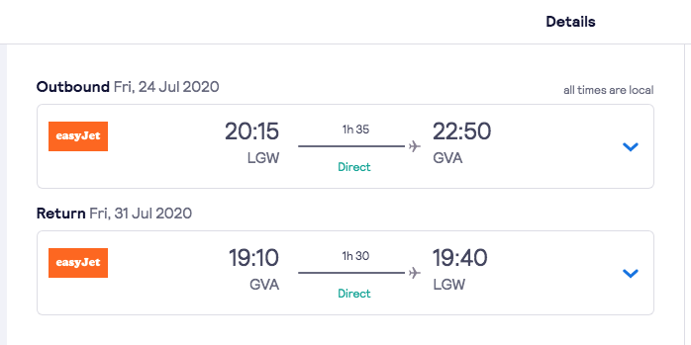

Add hotel and car hire

The last high priority change that should be introduced in the redesigning of Skyscanner is to eliminate diverting to the airliners website in order to complete the booking, preferring to enter all details in Skyscanner instead of going to another page format and layout which can create confusions for the user. When redesigning, the bookings page should stay on Skyscanner with a drop down page where the user can enter all their details including passport numbers, names, addresses and bank details for payments. Here is a screenshot: design for this:



Add hotel and car hire



# 

# 5. Discussion and Conclusion

The users chosen to take part in the usability testing were all from the younger generation age groups which included students with IT and analysis backgrounds. These ages were from 22 to 24 years old born in the age of technology. The reason for choosing this age group was because of their greater knowledge of the internet and technology, whereas an older generation age group would have less of these skills and knowledge. However, if I were to conduct the usability testing again, I would introduce an older generation group. Although they tend to be less tech savvy, they would provide a wider variety of opinions towards Skyscanner, enabling more improvements. Additionally, having chosen students with their own obligations, they perhaps did not spend enough time answering the questions and analysing the website, resulting to a less detailed analysis overall.

The tasks I chose for the usability testing were simple and to the point. From the basis of the tasks, if I were to do this again, I would explore other features of the website supplied for the user such as setting tasks to test the recommendations and offers sections of the website. This would allow me to expand the testing by exploring the website to a greater degree. Additionally, the majority of my participants already use Skyscanner for booking holidays and flights. This meant I received answers from those familiar and experienced with the site. However, if I included participants that are not familiar with Skyscanner, I believe I would have received different opinions and therefore a more well-rounded view of the site.

With the testing side of the analysis, I would have much preferred to do face to face testing with my participants, however the Covid-19 situation made this very difficult. Although using Zoom as an online based meeting session is similar, in my opinion, a face to face meeting may have created a better discussion and given me the ability to analyse the participant’s reactions towards any errors they came across with Skyscanner.

# 6. Appendices

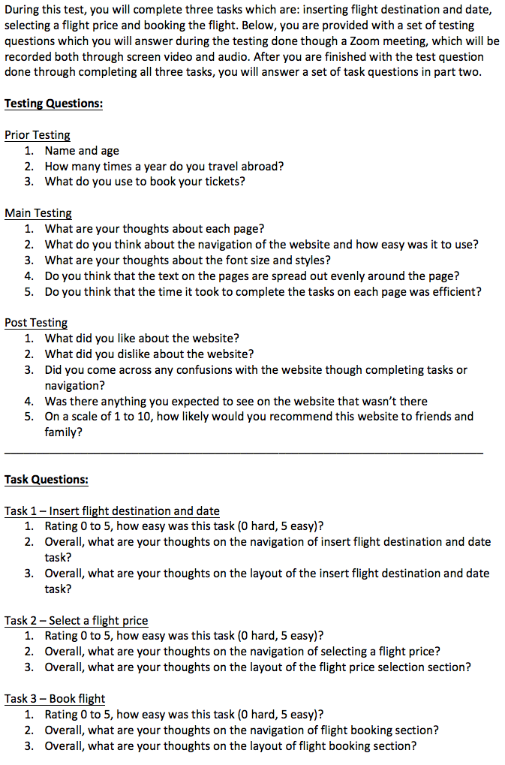Participant Information, Tasks and Question sheet

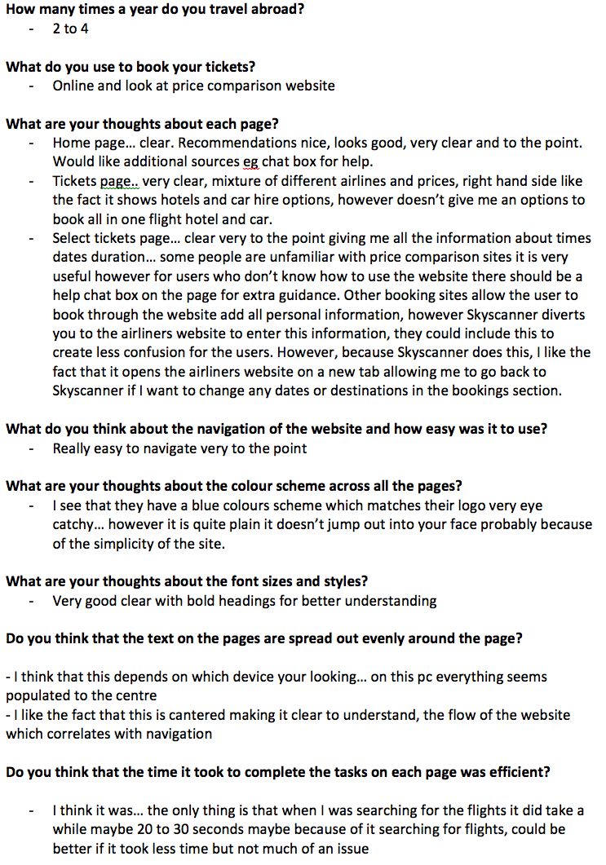Observation sheet with participant 1 example answers

